Employee center

This dynamic portal improves productivity by reducing time and effort employees spend accessing information across all departments. The **Employee Center** experience provides a platform for communication, engagement, and content experiences for internal employees.

The **Service Portal**provides a user-friendly self-service experience by providing access to specific features using widgets.

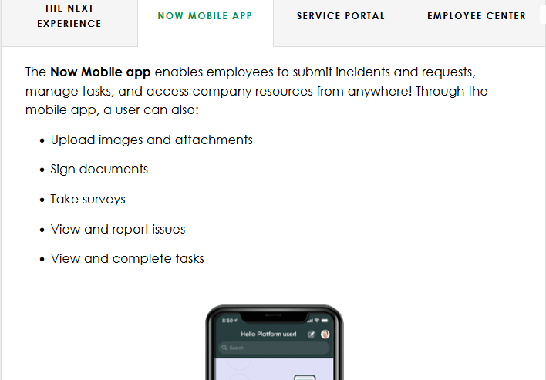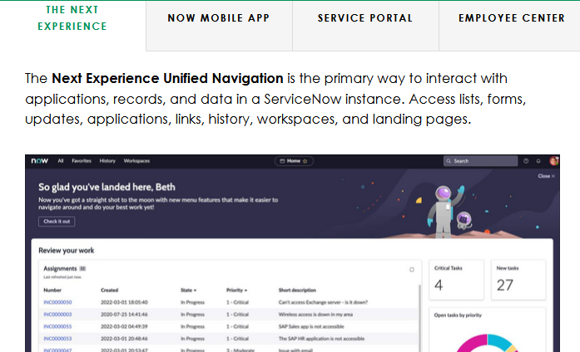

**What is an instance?**

When you are accessing ServiceNow, you are accessing an **instance** of the Platform. An organization can have several instances (e.g., Development, Quality Assurance (QA), Test, and Production) and each instance is a single implementation of the ServiceNow Platform.

An instance in the Platform is independent, changeable, and highly configurable.

Your data isn't mingled in the same database as another organization's data or other ServiceNow customers.

**Easy to migrate-🡪**data that can be exchanged between other instances. For example, it is easy for data to be migrated from a Development instance to QA, to a Production instance.

Table data displayed as lists

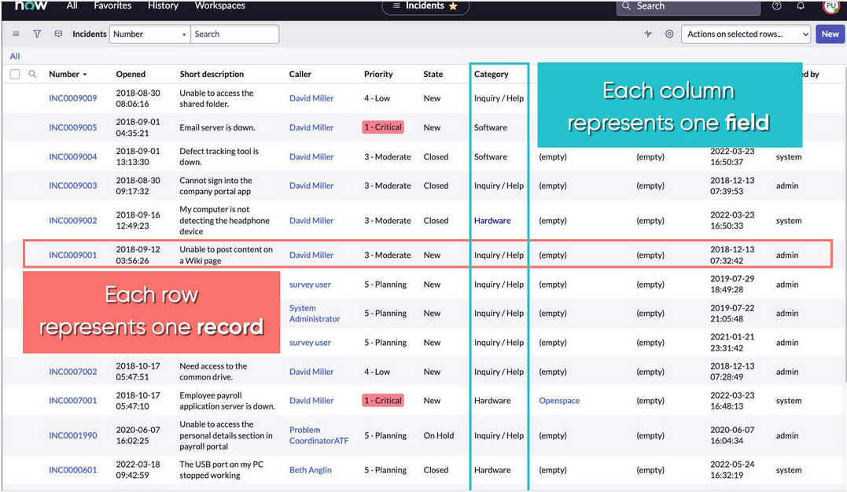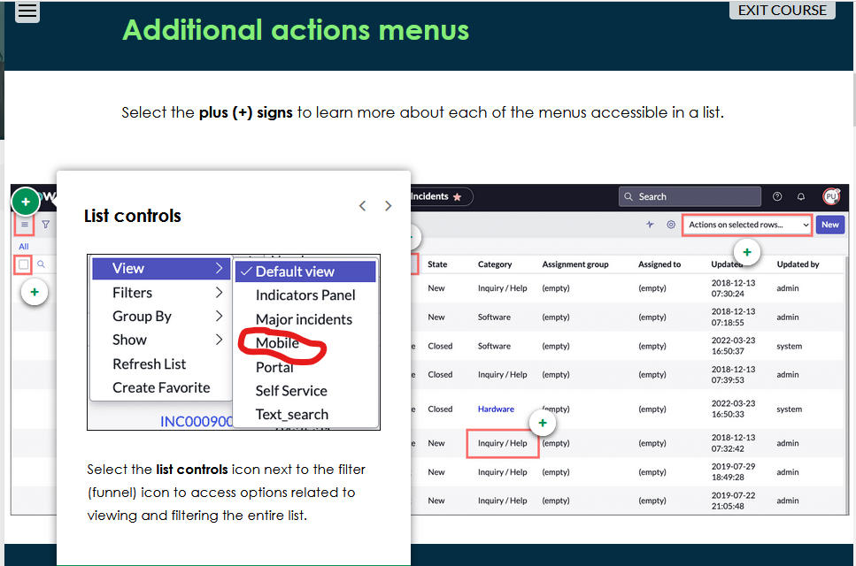

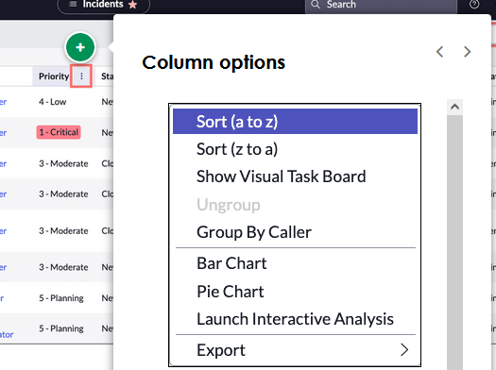

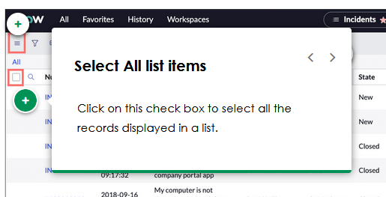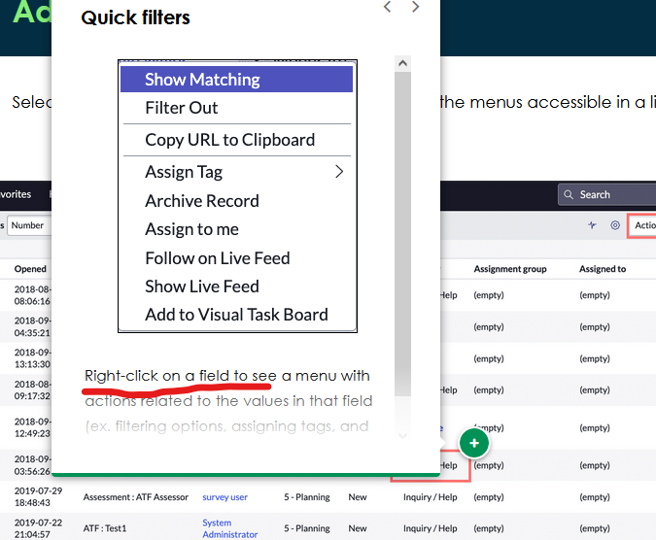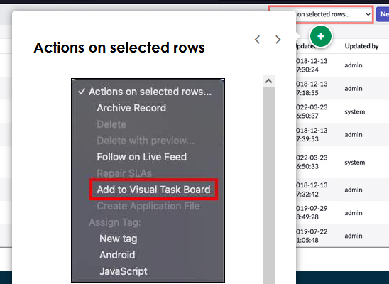

**Right-click on any field** and select**Show Matching** to show records like the one you are interested in seeing. For example, if you select Show Matching on a Priority 1-Critical incident, the quick filter will display a new list of all Priority 1-Critical incidents.

Filter out allows you to generate a new list of records without certain fields that you don't want to see. In this same example, if you **right-click** and select **Filter Out** on Priority 1-Critical incidents, the newly generated list will display all other records that are not Priority 1-Critical

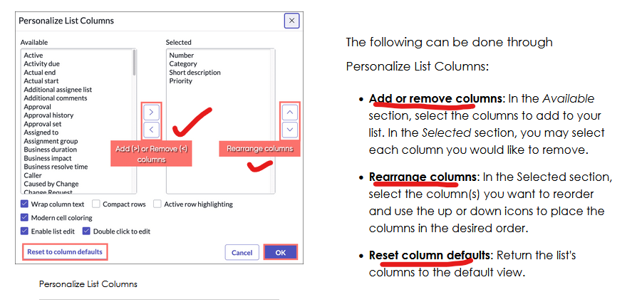

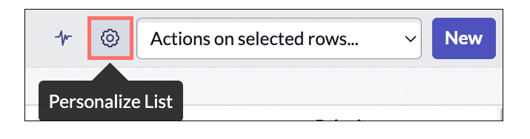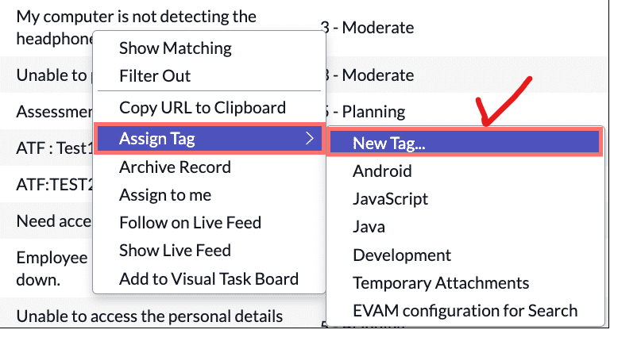

You may add a Tags column using the Personalize List Column, list collector. By doing so, you may **use in-line editing** to Add or Remove tags straight from the list view. To save a tag you've added through an in-line edit, you can press **Enter** on your keyboard or click any area on the list, outside of the newly added tag. If you would like to remove the tag, select the (**X**) to the right of the tag.

Knowledge management

**Knowledge Management** allows users to create, categorize, review, approve, and browse important information in a centralized location that is shared by the entire organization.

With Knowledge Management, each organization can have their own **Knowledge Base (KB)** with flexible controls over who can see the information and who can help develop its content

Knowledge management architecture---:

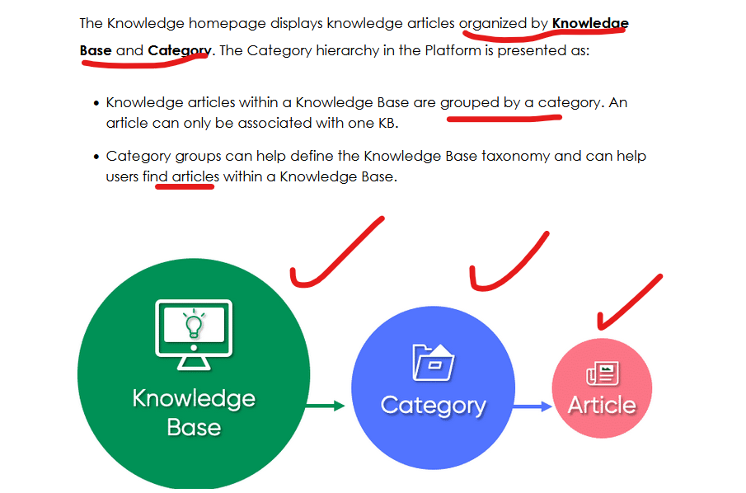

**Rating articles and feedback**

When viewing Knowledge content, you may rate, see the number of views, flag, create an incident, mark as helpful, and leave comments.

Flag🡪Selecting the Actions menu allows you to **flag** **an article** and provide a reason as to why you believe it is incorrect or inappropriate.

User criteriea🡪 Administrators can create multiple Knowledge Bases and assign them to individual users in the Platform. This is called **User Criteria**.User Criteria defines conditions that are evaluated against users to determine which users can **create**(upload or author), **read**(view), **write** (edit), and **retire** (make articles inaccessible to all users) knowledge articles.

Only those with the appropriate permissions can apply User Criteria records to Knowledge content.

Service catalog-:

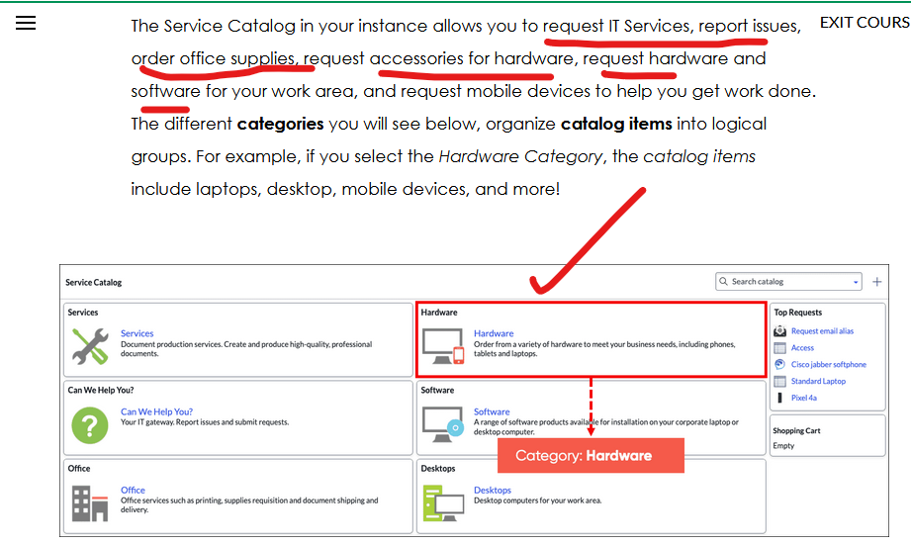

Requests Requested items tasks

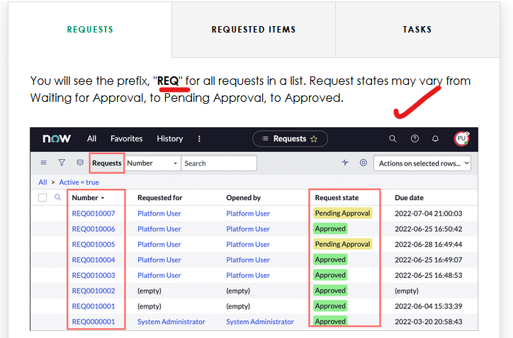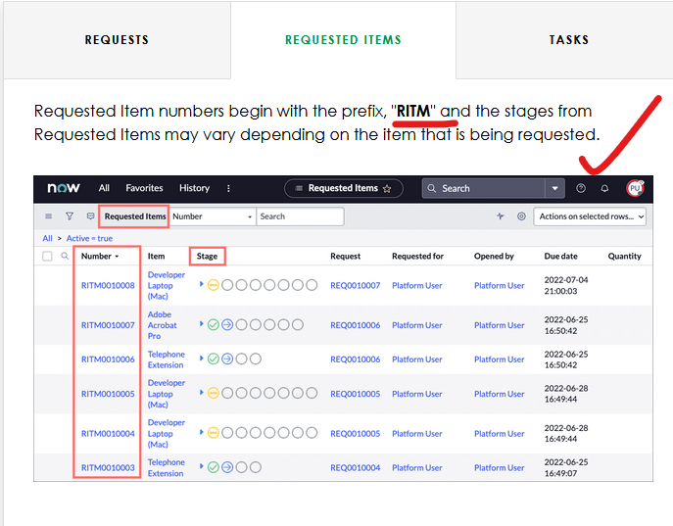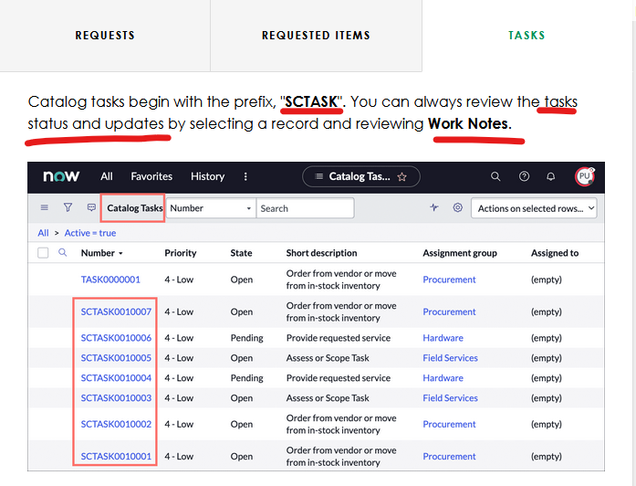

Virtual agent🡪 powered by ai

**Virtual Agent (VA)** is a friendly messaging interface that provides immediate help in the Platform, day or night! VA helps you make decisions, perform common work tasks, and browse information stored in Knowledge Bases, Service Catalog, and more! It offers a web-based interface available to Service Portal, iOS, and Android mobile environments, as well as third-party messaging applications through ServiceNow adapters for Slack and Microsoft Teams.

* Answering FAQs
* Providing tutorial ("how to") information
* Querying or updating records (get statuses on cases or incidents)
* Gathering data (ex. attachments) for agents
* Performing diagnostics
* Resolving multi-step problems
* Working with file attachments during the live chat
* 